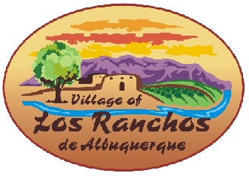

Citizens Advisory Committee
Wednesday, August 23, 2023
9:00-10:30 a.m.
Warren J. Gray Chambers,
Village Hall 6718 Rio Grande Blvd NW
Los Ranchos, NM 87107

Agenda
- Report backs—Ann, Atty; George, Developer; Robert, Banker
- Discussion of revised table requirements
- Public Comments
- Adjourn

