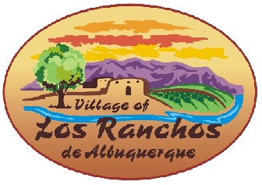

Citizens Advisory Committee
Wednesday, November 1, 2023
9:00-10:30 a.m.
Warren J. Gray Chambers,
Village Hall 6718 Rio Grande Blvd NW
Los Ranchos, NM 87107

Agenda
- Define Open Space/Conservation
- Summary of proposed changes to Pilot Conservation Ordinance
- Discussion of public meeting process/schedule
- Discussion of next CAC task: VC Zone or Subdivision Ordinance proposed changes
- Public Comments
- Adjourn

